

System Overview Report

Version 1.2

**Jack Irving;**

**Fangfang Huang**

**Nasser Aloqayli**

**Jack Irving;**

**Fangfang Huang**

**Nasser Aloqayli**

Table of Contents

1. System Vision: 2

*1.1 Project description:* 2

*1.2 System capabilities* 2

1.2.1 Scope – People, Activities and Context 2

*1.3 Business benefits* 3

2. Systems requirement 4

*2.2 User Stories:* 4

*2.2 Conceptual data model* 5

2.3 Proposed system architecture overview 6

*2.4 Delivery cycle plan* 7

3. Project organization 8

*3.1 System Development Approach* 8

*3.2 Team structure* 8

*3.3 Overall Project Plan* 8

3.3 Risk Management Plan 9

4. Client Sign Off Statement 9

5. Appendices: 10

*5.1 Meeting minutes:* 10

1. System Vision:

***1.1 Project description:***

Crafty Cuts Laser has Australia’s largest & best range of laser cut supplies. It’s owned and managed by Bec Albinson and her husband Jon Vincent. The business started in 2006 and since 2013 has been using Etsy. They offer pre-made creative and fun products for independent hobbyists and design-based businesses. Their current business model is cut their current business model is to make to order individual bits. With a very diverse group of customers the majority of customers are wholesalers who orders in large quantities.

Currently Bec’s business is using ETSY as the main selling platform. ETSY is a peer-to-peer e-commerce platform for people to buy or sell handmade items and supplies.  However, the main issue of the ETSY is its inability to efficiently manage large amounts of stock. Making what should be a simple process extremely time consuming.

The business has reached a point where it has outgrown ETSY’s capabilities. The costs of running the e-store combined with its lackluster, user experience and poor inventory management functionalities has resulted in our client to look for a standalone website for selling and managing their own products.

***1.2 System capabilities***

### 1.2.1 Scope – People, Activities and Context

There are **two stakeholders** for the proposed system. The first stakeholder are the **customers** who use and interact with the system to browse offerings, make purchases, track sales and ask questions. **Customers** will be split up into **wholesalers** and **retail**. The second stakeholder are the **administrators** who are also the **owners** and **operators** of the website.

Customers and visitors of the website will be able to login or register for accounts, search for products, save items to their wish lists and buy items online. Depending on the amount and total value of items bought retail customers will receive an automatic discount. The discount ranges will be shown when the customer is viewing the item listing so as to help inform them of how much they need to buy to receive a discount. Wholesale customers receive specific discounts set by the client.

For each item listing, customers will be able to view all available, sizes, materials and styles that each listing offers. Finally customers both wholesale and retail will be able to click on a link which will take them to a contact portal so they may receive customer support with regards to that specific listing.

Our client, which is the admin of the system will have privileges such as adding new items, removing items, view all customers, send newsletters, review history of items sales and manage stock. Each listing has a finite amount of stock available, once the stock has run out, the listing will automatically reflect this and alert client that an item is out of stock. Client can then input new stock at will. The system will not allow for backorders, however the customer can still use the contact portal to contact the client with regards to ordering said item.

Access to the website will be through a web browser, which will also have support for mobiles and be mobile friendly. This is particularly important because our client interacts with the website on her phone on a frequent basis. Crafty cuts doesn’t have a physical store front so all interactions with the business are done online.

***1.3 Business benefits***

The major benefit to the business from implementing the new system will be timesaving. Currently many hours are being wasted by the current system’s poor inventory management functionality, by being able to manage stock listings more efficiently both time and money will be saved.   
  
If a base material is out of stock for example a yellow acrylic sheet, then all items which have yellow base material must reflect that yellow is out of stock. This is a huge issue because if the client wants to remove yellow from her listings then she needs to go to each individual listing and reflect that change. This is a huge issue for her, currently the client has 600+ items listed, each listing has multiple styles and sizes. So when a colour material becomes out of stock it is a major hassle to manually change all those listings and sub-listing.

Secondly, an improved user experience should help alleviate some of the stresses that many return customers have. A major issue identified by the client was after a customer added an item to the cart if they wanted to add another identical item but in a different colour or size offering they need to click back and do it all over again. This meant that wholesalers who might order many different colours of the same product were wasting a lot of time. The new system will address them by allowing, items to be added to the cart without taking the user directly to the cart. Cart management by not taking the user directly to the cart of if it does then have the option to add another item to the cart near the item listing.

Finally both retail customers and the client will save time because many of the issues arise because of the poor interface design by Etsy. By removing these constraints the number of queries that the client has to deal with will be cut down saving both times and resources. Things such as customers forgetting to input the discount codes or not reading what items are in stock. All these have to do with the layout of the information and how it is not being efficiently or effectively communicated to the users. The new system will fix these issues.

2. Systems requirement

*2.1 Functional Decomposition Diagram*

*insert FDD*

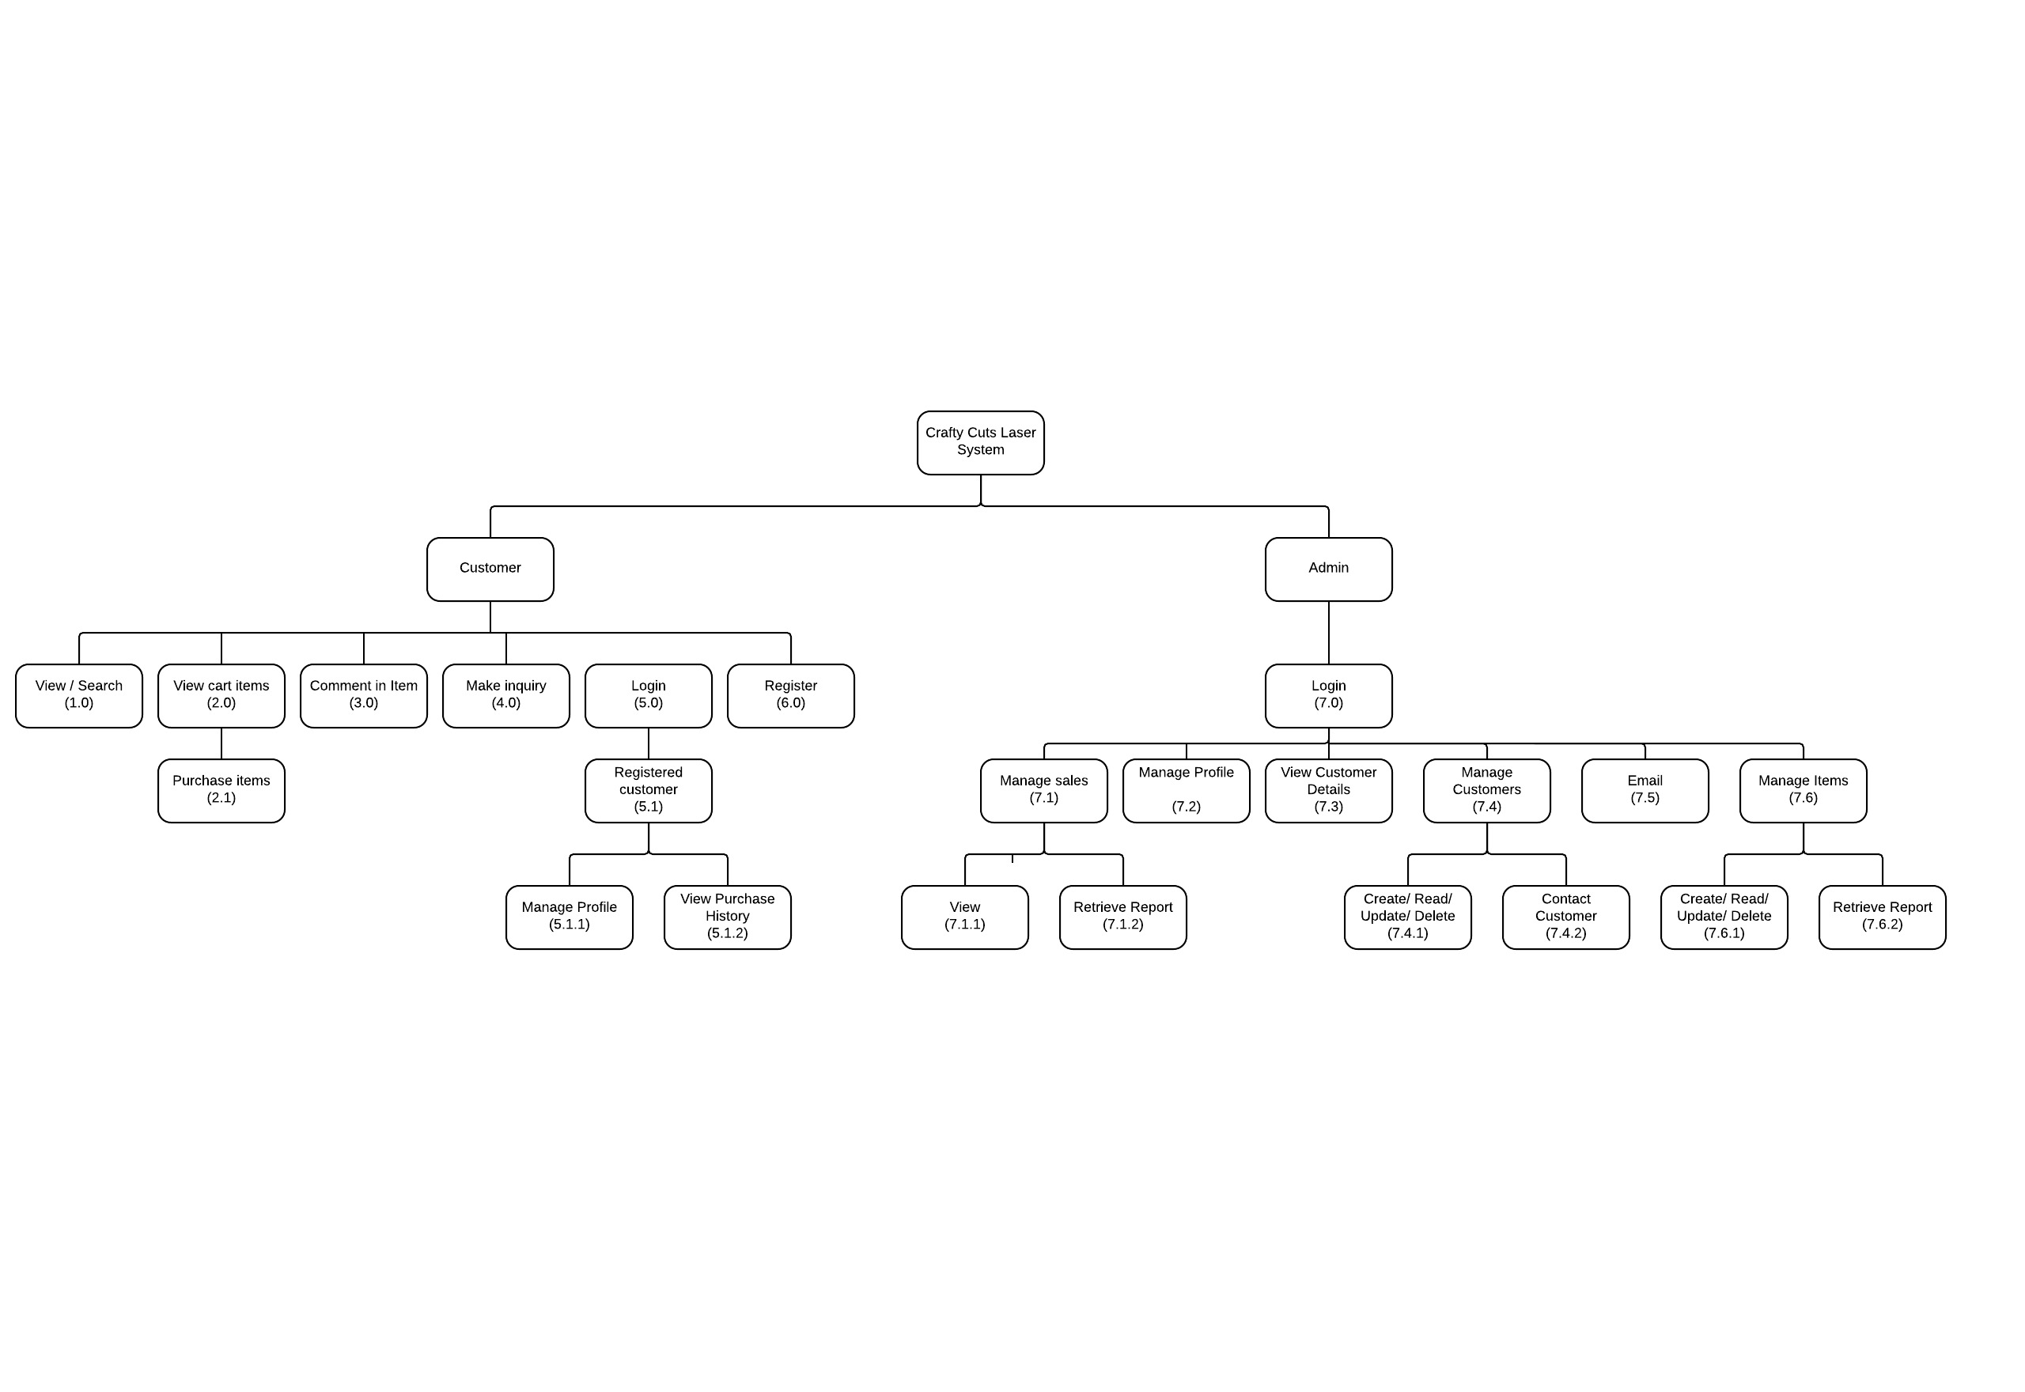

Subsystems Description

* **View/Search (1.0):** A website customer can view the website as well as search for specific item.
* **View Cart Items (2.0):** A customer can view all the selected items in the shopping cart. Also, a customer can purchase them **(2.1)**.
* **Comment(3.0):** A customer can make a comment on any items on the website.
* **Make Inquiry(4.0):**  A customer can make an inquiry to the admin about any item .
* **Login (5.0):** A registered customer can login to his/her account **(5.1)**. When customers successfully logged in, they can manage their profile **(5.1.1)**. Also, they can review their history of purchases **(5.1.2)**
* **Register (6.0):** A customer would be able to register in the website.
* **Login (7.0):** An admin can login to the system to exercise activities such as:
  + **Manage Sales (7.1):** Such as view new sales**(7.1.1)** and retrieving reports**(7.1.2)**.
  + **Manage Profile (7.2):** Such as updating any details.
  + **View Customer Details (7.3):** An admin can see all the details of the customers.
  + **Manage Customers (7.4):** An admin can create, read, update and delete customer account**(7.4.1)**. Also, an admin can contact the customer**(7.4.2).**
  + **Email (7.5):** An admin will be able to view his/her email through the dashboard.
  + **Manage Items (7.6):** An admin can create, read, update and delete any items**(7.6.1)** in the website. Also, an admin can retrieve a report of all items**(7.6.2)**

***2.2 User Stories:***

**Role: Customer**

|  |  |  |
| --- | --- | --- |
| As a | I want to... | So that... |
| Customer | Register a unique account | I can shop |
| Customer | Log into my account | I can view my shopping history |
| Customer | Be able to edit and update my profile | My orders arrive at the right destination |
| Customer | Be able to edit and update my profile | My contact details are correct |
| Customer | Be able to search for a particular item | I can purchase it |
| Customer | Be able to view pictures of items | I can preview them |
| Customer | View product details | I can purchase the correct item. |
| Customer | Check items availability | I can purchase them. |
| Customer | Read reviews of an item | I know others view about the item. |
| Customer | Write my own review | I can discuss with other reviews. |
| Customer | Choose different colors of the item | I know the differences. |
| Customer | Choose different sizes of the item | I can see how it looks like. |
| Customer | Create cart | I can purchase many orders. |
| Customer | Check my cart | I can edit/update any item. |
| Customer | See the total price and discount | I can buy more. |
| Customer | Check out | I can pay for my shopping. |
| Customer | Choose payment method | I can pay as it suites me. |
| Customer | Be notified if I deserve discount | I can buy more. |
| Customer | Know how much is GST | I can decide whether to buy or not. |
| Customer | Know shipping method | I know how long delivery will take. |
| Customer | Be able to view shopping history | I know what I did buy. |
| Customer | Be notified when a payment is made | I can make sure it is done. |
| Customer | Be able to browse from my phone | I can buy products. |

**Role: Administrator**

|  |  |  |
| --- | --- | --- |
| As an | I want to... | So that... |
| Admin | Login | I can manage my products. |
| Admin | Edit/update my profile | Customer can reach me. |
| Admin | Be able to edit customers’ details | I can fix any inappropriate details. |
| Admin | Be able to delete customer account | Inactive customers do not exist. |
| Admin | Know when items are running out | I can order more products. |
| Admin | Be able to add new items | Customer can buy them. |
| Admin | Be able to delete items | Unavailable items do not appear. |
| Admin | Be able to change the availability of items | Customer can see that. |
| Admin | See all the details of customers | I can make offers for them. |
| Admin | Get report of items or customers | I know my business progress. |
| Admin | Send newsletter | Customer gets to know the new items or offers. |
| Admin | Filter customers or items | I can check their status. |
| Admin | Be notified if an item is sold | I can send to shipment. |
| Admin | Record each completed sale | I can get report each month. |
| Admin | Write a comment/review | Other customer can get clarified. |
| Admin | Know active customers | I can allocate some feature/offers to them. |

***2.2 Conceptual data model***

Below is the ER-diagram of Crafty Cuts Laser, it represent the business rules of the organizations.

Notes:

1. Assume customer can only check out through shopping cart.
2. There is no GST for international customer. Tax Class to determine if the customer’s price should include GST or not
3. Customer can choose to write a review or not
4. Customer can check out as a guest and a exist customer. Shipping detail needed if customers check out as a guest.
5. Shopping cart details should be saved, hence, we can email customer to remind them to check their shopping cart.

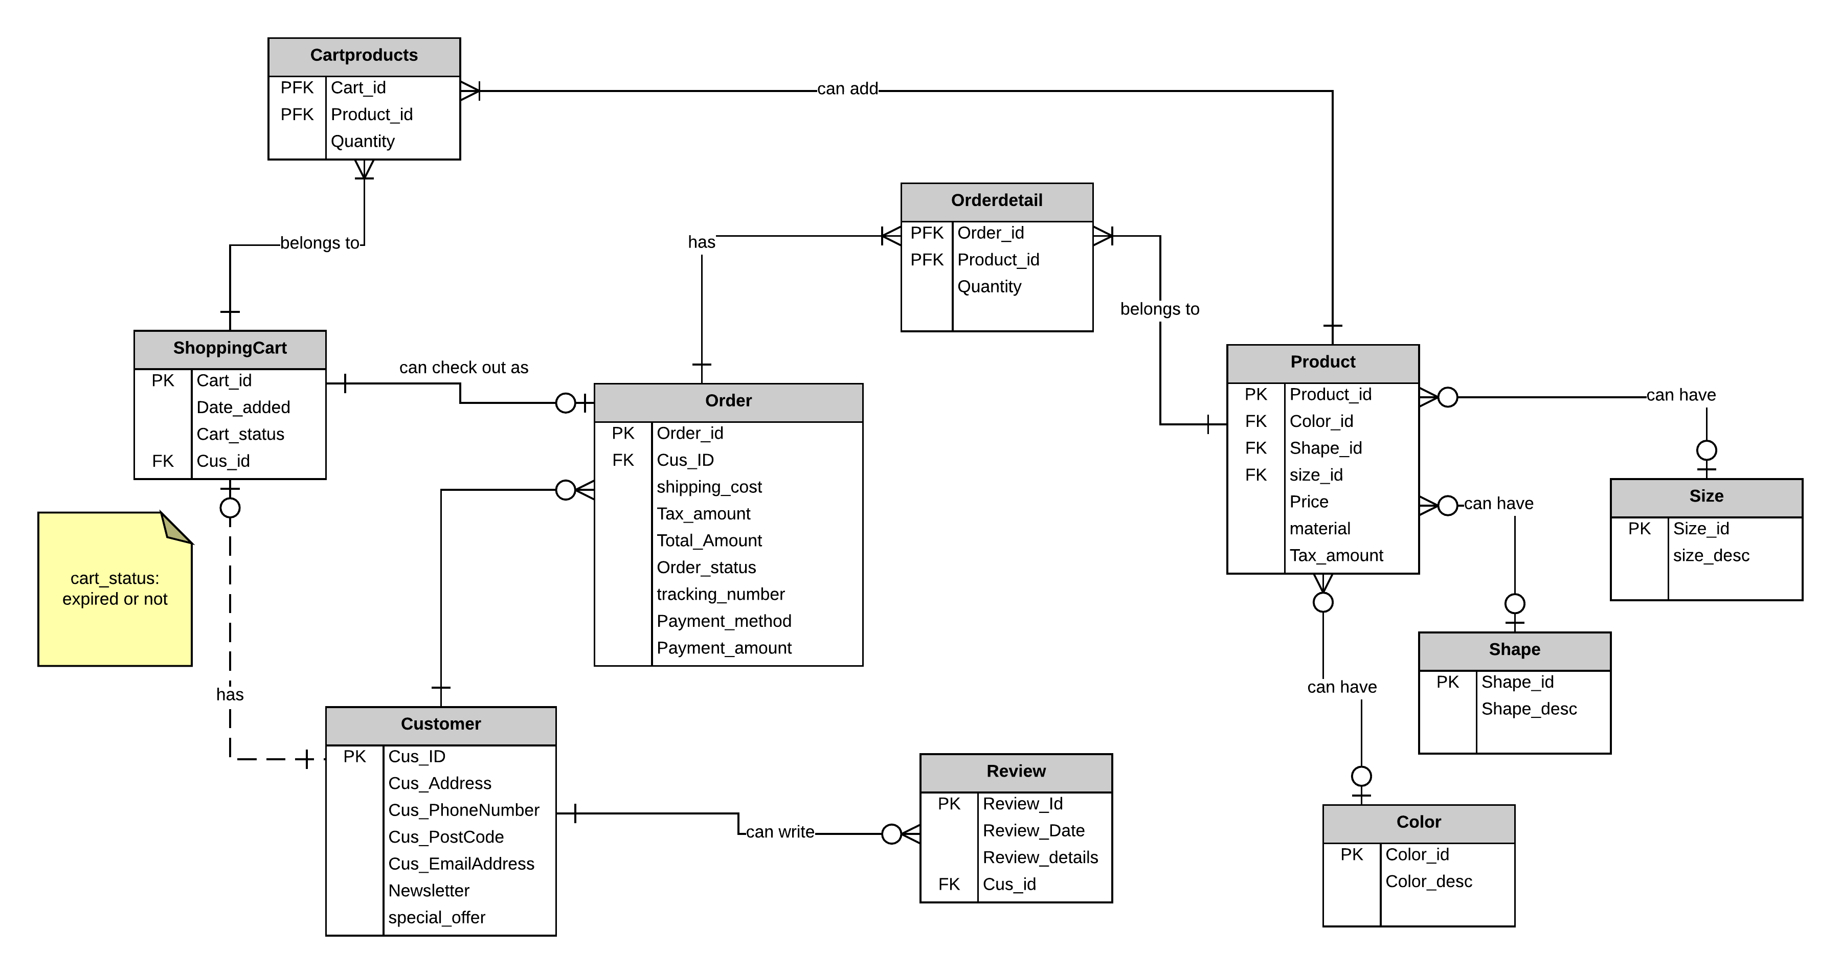

**2.3 Proposed system architecture overview**

Currently the client accesses Etsy through her computer or phone. Our client doesn’t have her own website or webhosting. The client does not have access to the backend of Etsy. The business is primarily dependent on Etsy. This means if Etsy goes down for any reason the client is unable to continue business.

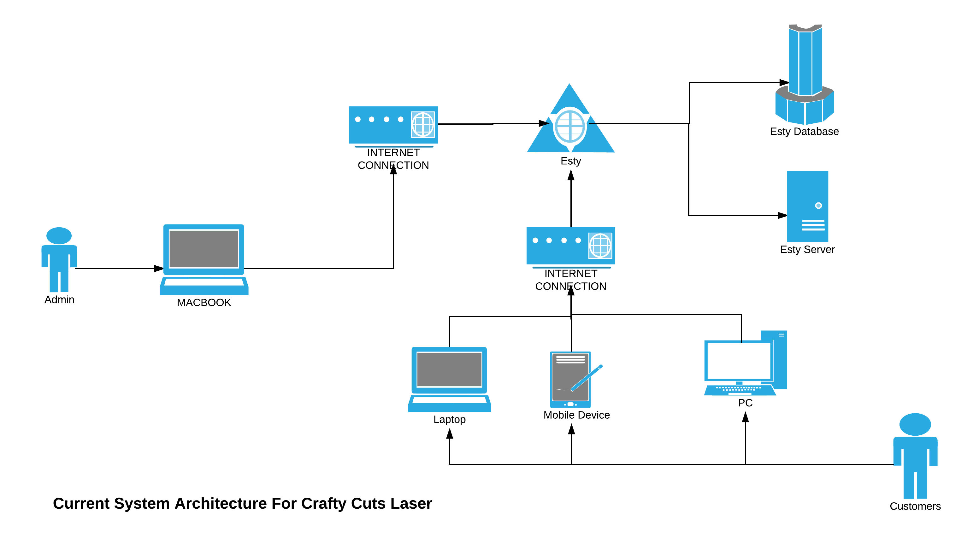

In the new system the client will have her own standalone website which is hosted along with the database. The system’s uptime can be controlled by the client, as well as full back end access.

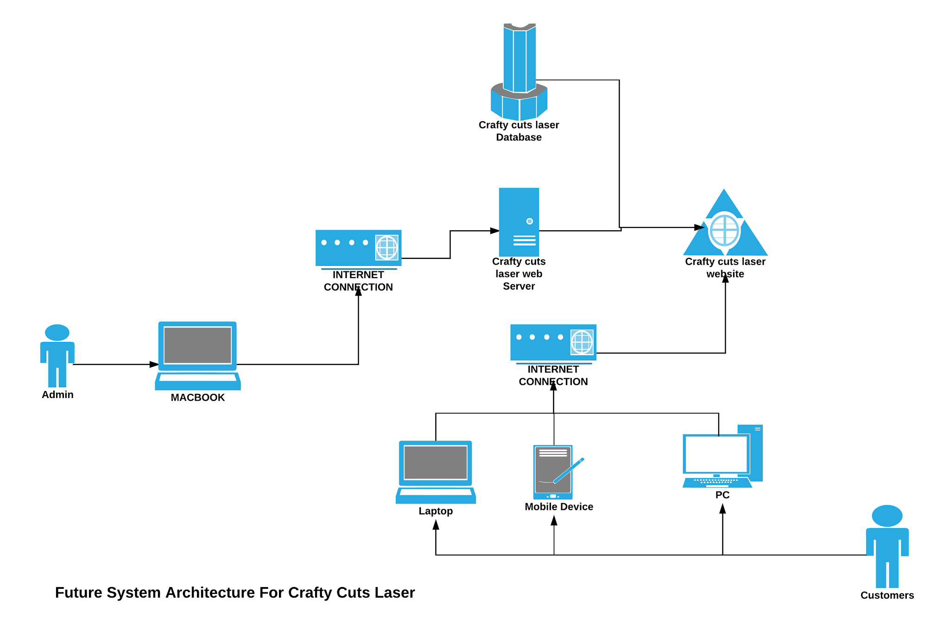

***2.4 Delivery cycle plan***

|  |  |  |
| --- | --- | --- |
| Delivery cycle | Tasks | Delivery Date |
| Delivery Cycle 1 | * System Overview * Basic website design * 1.0 View/search * 2.0 View cart items * 5.0 Login(All) * 6.0 Register | **23-Sep-2015** |
| Delivery Cycle 2 | * Review DC1 * 3.0 Comment in item * 4.0 make inquiry * Admin View * 7.0 Admin Login * 7.2 Manage Profile | **14-Oct-2015** |
| Delivery Cycle 3 | * Review DC2 * 7.1 Manage Sales * 7.4 Manage Customer * 7.3 View customer Details | **30-Nov-2015** |
| Delivery Cycle 4 | * Review DC3 * 7.5 Email * 7.6 Manage Item | **10-Dec-2015** |

3. Project organization

***3.1 System Development Approach***

The system development will be taking an iterative approach method. This means the whole project will be divided into 4 main delivery cycles.

***3.2 Team structure***

|  |  |  |
| --- | --- | --- |
| **Team Member & Email** | **Role** | **Role Description** |
| Jack Irving  Jlirv2@student.monash.edu | Team Leader & Developer | Responsible for ensuring that everyone within the team understands and executes their role to the expectation of the project objection. |
| Fangfang Huang  vatid1@student.monash.edu | Client Liaison & Developer | Accountable for the overall communication flow between the project team and client. |
| Nasser Aloqayli  nmalo@student.monash.edu | Developer | Assists with all aspects of the project’s development and implementation process. |

***3.3 Overall Project Plan***

|  |  |
| --- | --- |
| **Task Name** | **Delivery Date** |
| System overview Report | 02-Sep-2015 |
| Delivery Cycle 1 | 23-Sep-2015 |
| Delivery Cycle 2 | 14-Oct-2015 |
| Implementation Plan Deliverable | 21-Oct-2015 |
| Delivery Cycle 3 | 30-Nov-2015 |
| Delivery Cycle 4 | 10-Dec-2015 |
| Client Acceptance Test Sign-off | 14-Jan-2016 |
| Final Build | 19-Jan-2016 |
| Mini Expo | 22-Jan-2016 |
| Post-Implementation Review | 29-Jan-2016 |

**3.3 Risk Management Plan**

|  |  |  |
| --- | --- | --- |
| **Risk** | **Risk Description** | **Mitigation Strategies** |
| **Client unavailability** | During the Christmas shopping period, our client is very busy filling orders. Her working schedule goes to practically 7 days a week. This busy shopping period | This risk is mitigated by shortening our meeting times from 1-2 hours to a much more manageable 15 minutes briefing. The briefings will be at our clients’ place of work. This will eliminate the need for our client to travel and set aside long periods of the day to meet with us. |

4. Client Sign Off Statement

**I ______________________ of ___________________ agree that this system overview report currently covers my requirements with the understanding that any changes discussed will be made. Also, I understand that I may make changes throughout the project.**

**______________________**

**Client Signature & Date**

**______________________**

**Team Representative & Date**

5. Appendices:

***5.1 Meeting minutes:***

Meeting Minutes - Crafty Cuts Laser project

**Location:** *Building H – Level 6 - Room 97 / Monash Caulfield Campus*

**Date:** Wednesday 19/08/2015

**Start Time:** 8:30 AM

**End Time:** 10:30 AM

Attendance:

* Bec Albinson, the owner of Crafty Cuts Laser
* Jake Irving – Project team leader
* Fiona Huang – Client liaison
* Nasser Aloqayli – Builder

Apologies:

Non

**Approval of agenda:**

The agenda was unanimously approved as distributed.

**Agenda Items:**

1. Overview of the current system processes.
2. Shopping and searching issues.
3. Making payment process and shipment.
4. Stock process and issues.
5. Customer account, discount and privileges.
6. Admin account, monitor and records.

**Items discussed:**

1. Customers’ functions as Etsy website, the current system.
2. New customers’ function is when shopping should wait until checkout request is made.
3. Customer privileges or discount should be depending on the total price.
4. Customers’ membership, account and newsletter.
5. Shipping and payment details.
6. Items removal from the website depends on the stock availability.
7. Items availability (color and size) shown in the website.
8. Admin adding new items.
9. Admin account and dashboard.
10. Listing items and sorting them feature.

**Other Notes**

* Client will provide screenshots of the admin pages.
* Client will provide links to other pages that should follow same style.

**Agenda for next meeting**

* Next meeting is on Monday next week (Not official).
* Discuss event progress and confirm process.
* Discuss possible times to meet up and prepare any document.

**Next meeting**

The next meeting will be at 2:00 pm, Monday, at Building H, Level 6, Room 97 Monash Caulfield Campus.

**Meeting closed**

Meeting was adjourned at 10:30 AM.

**Minutes submitted by:**

Nasser